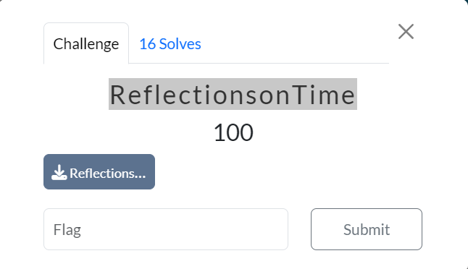

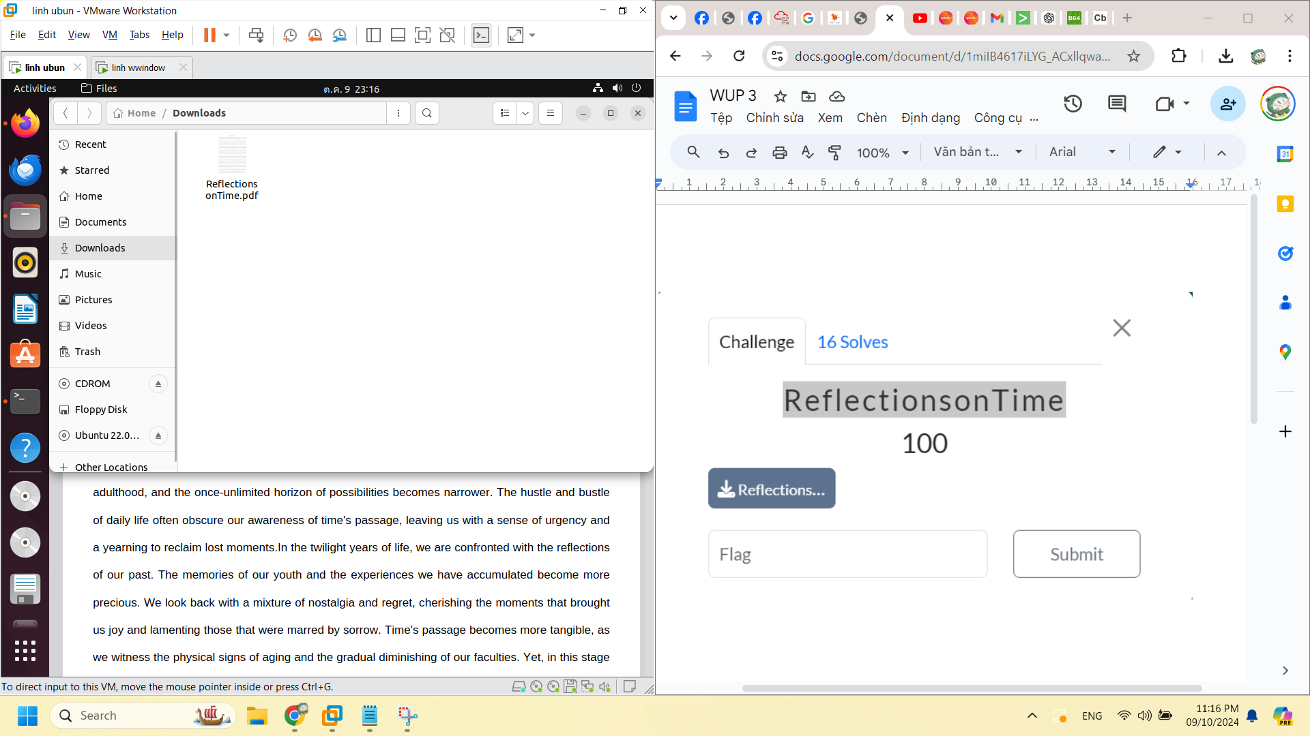

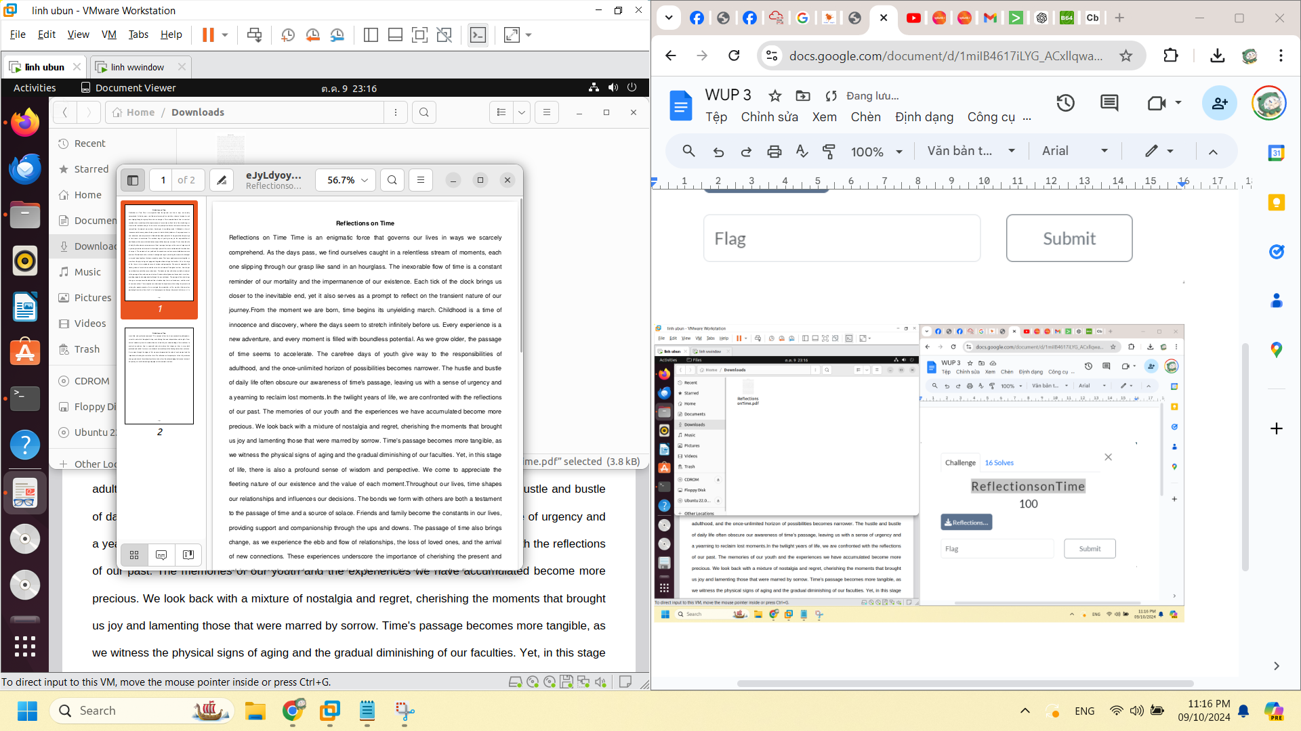

strings ReflectionsonTime.pdf

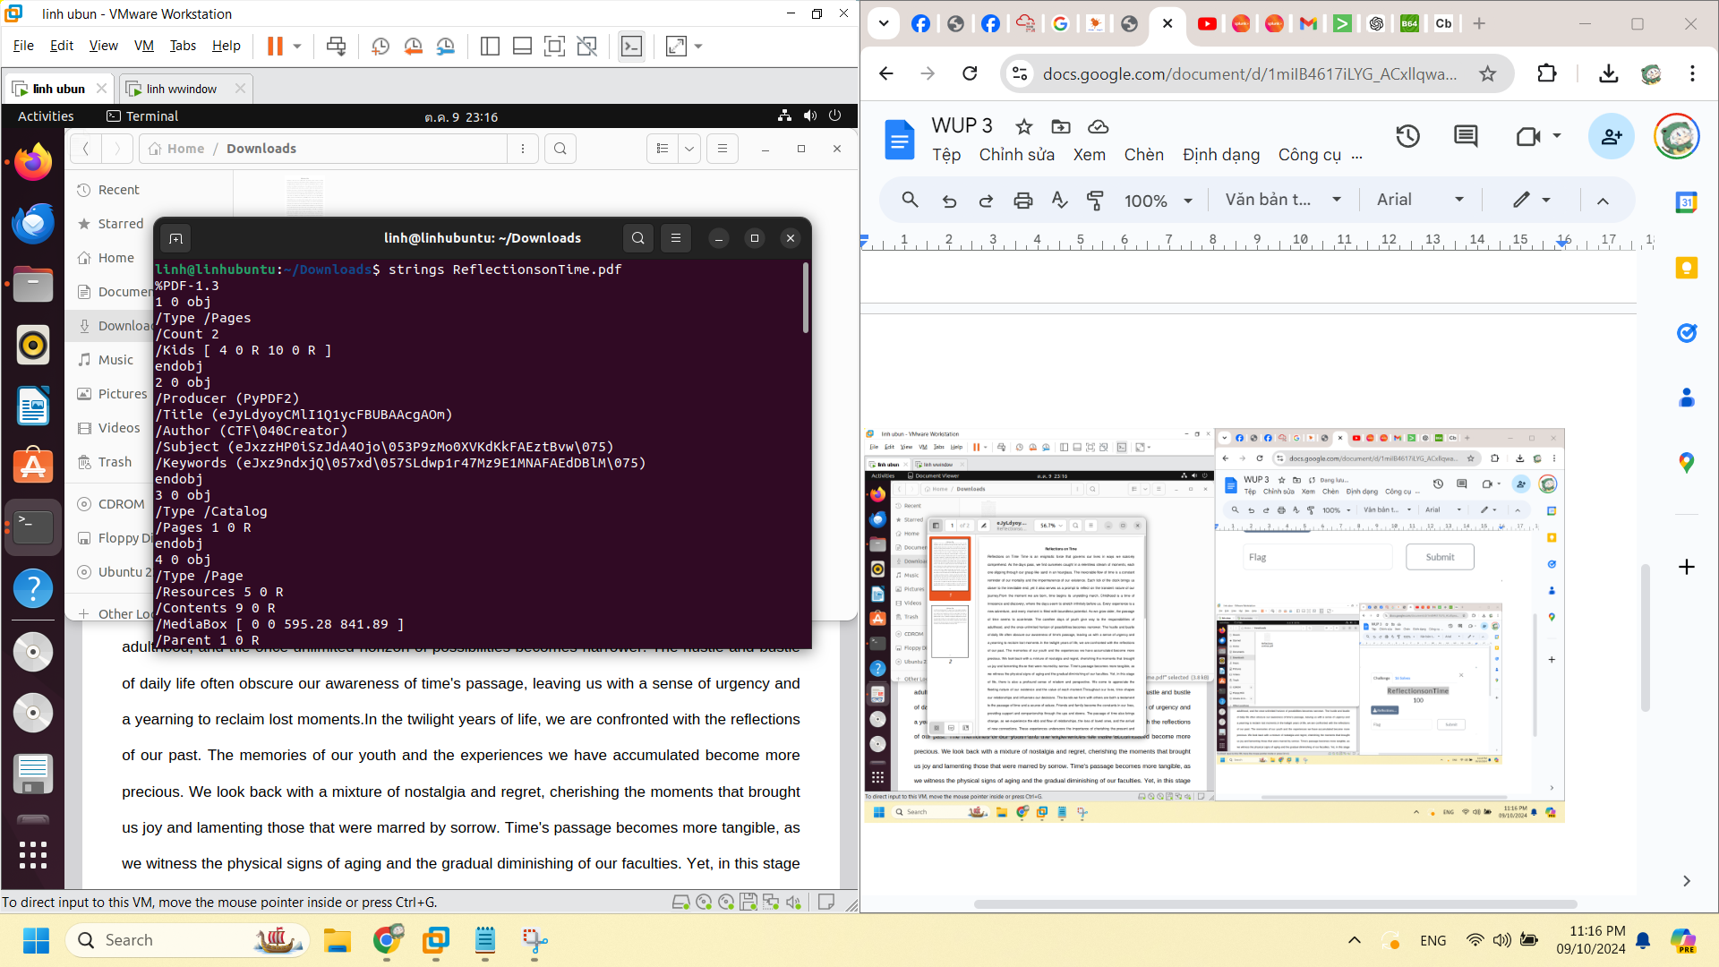

binwalk ReflectionsonTime.pdf

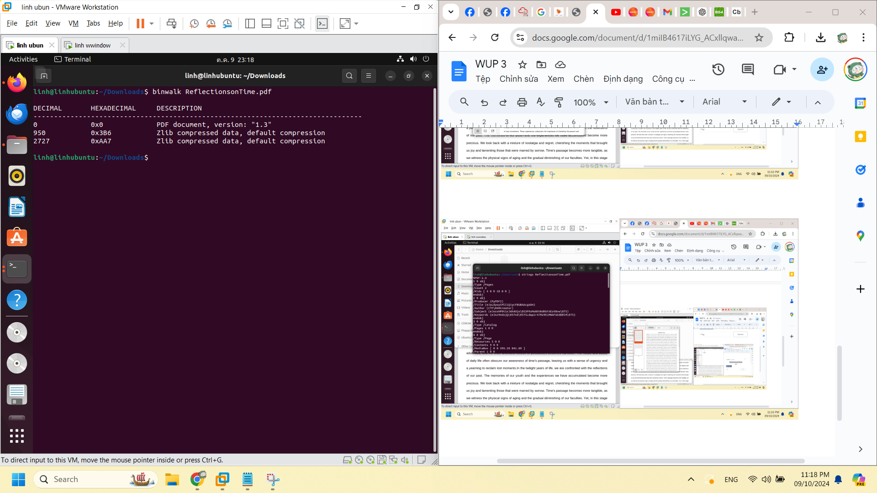

exiftool ReflectionsonTime.pdf

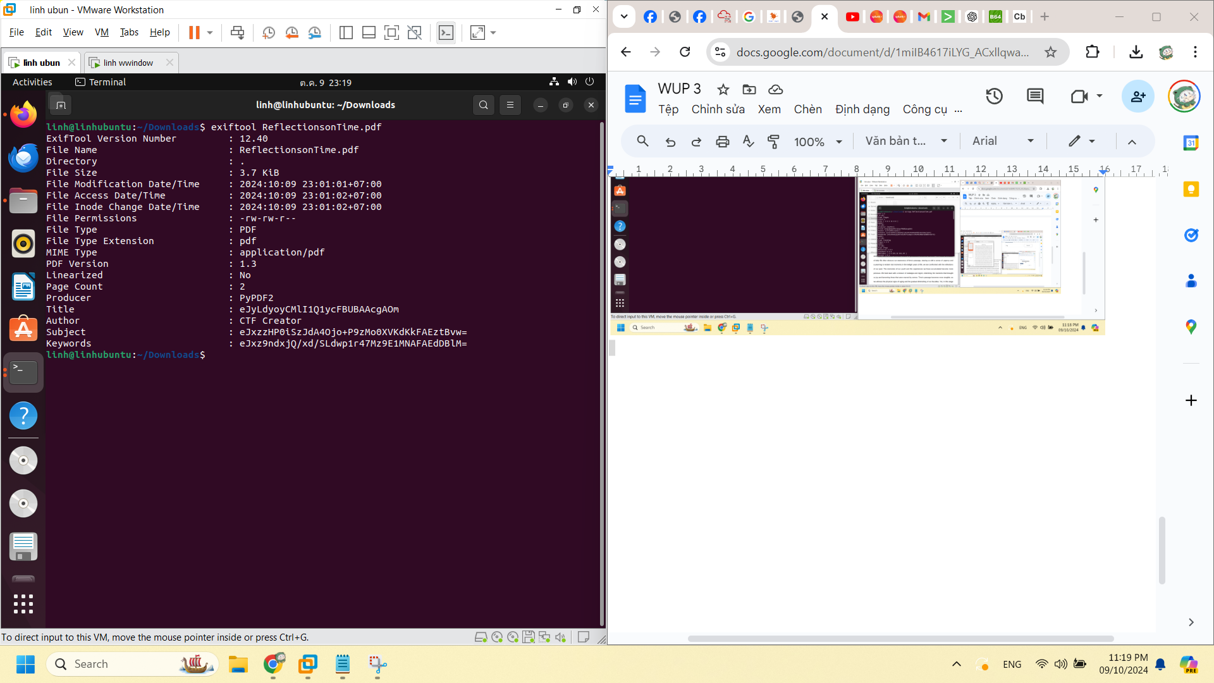

Title : eJyLdyoyCMlI1Q1ycFBUBAAcgAOm

Subject : eJxzzHP0iSzJdA4Ojo+P9zMo0XVKdKkFAEztBvw=

Keywords : eJxz9ndxjQ/xd/SLdwp1r47Mz9E1MNAFAEdDBlM=

decode = zlib

**Title**: _Br0The-R@@!!

**Subject**: AnALYtiCSS___N0t-BaD}

**Keywords**: CODE_TOAN_BUG{Yol-00-

CODE_TOAN_BUG{Yol-00-_Br0The-R@@!!AnALYtiCSS___N0t-BaD}